Supplementary tables and figures

Table S1. Description of identified COG pathways.
COG ID | Description
COG1600 | Uncharacterized Fe-S protein
COG4938 | Uncharacterized conserved protein
COG2026 | Cytotoxic translational repressor of toxin-antitoxin stability system
COG4463 | Transcriptional repressor of class III stress genes
COG0386 | Glutathione peroxidase
COG0045 | Succinyl-CoA synthetase, beta subunit
COG2153 | Predicted acyltransferase
COG1783 | Phage terminase large subunit
COG3463 | Predicted membrane protein
COG4330 | Predicted membrane protein
COG4545 | Glutaredoxin related protein
COG0252 | L-asparaginase/archaeal Glu-tRNAGln aminotransferase subunit D
COG4880 | Secreted protein containing C-terminal beta propeller domain distantly related to WD-40 repeats
COG1252 | NADH dehydrogenase, FAD-containing subunit
COG1618 | Predicted nucleotide kinase
COG1036 | Archaeal flavoproteins
COG5026 | Hexokinase
COG4146 | Predicted symporter
COG4542 | Protein involved in propanediol utilization, and related proteins (includes coumermycin biosynthetic protein), possible kinase
COG4283 | Uncharacterized conserved protein

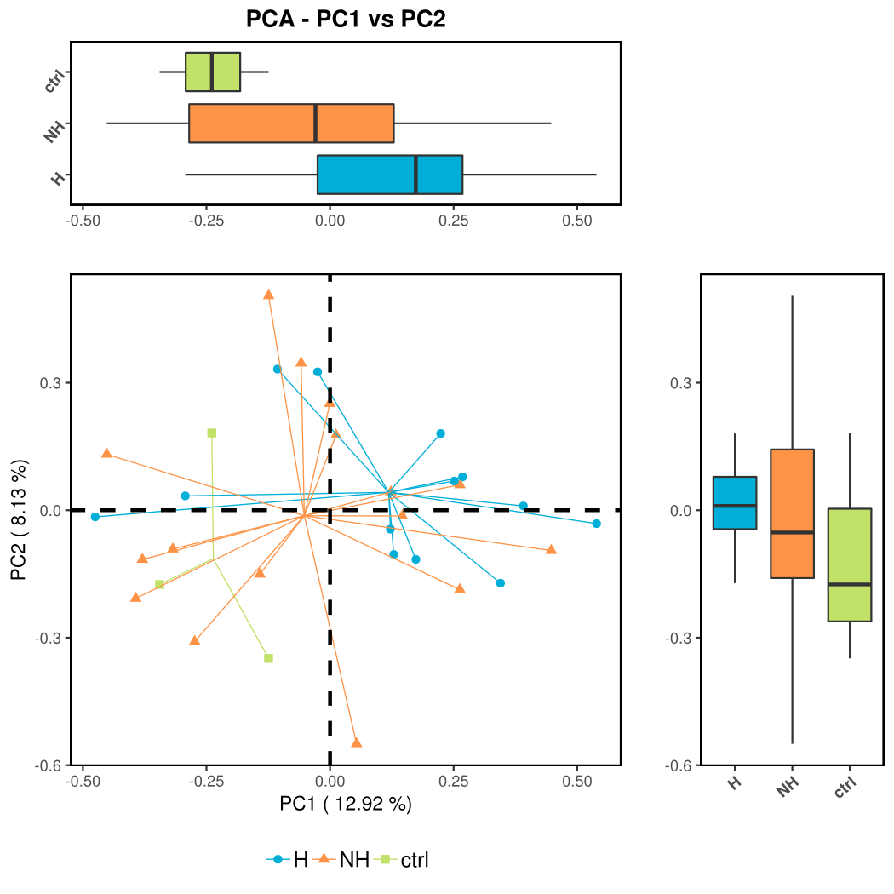
Figure S1. Ordination plot with principle component analysis (PCA).

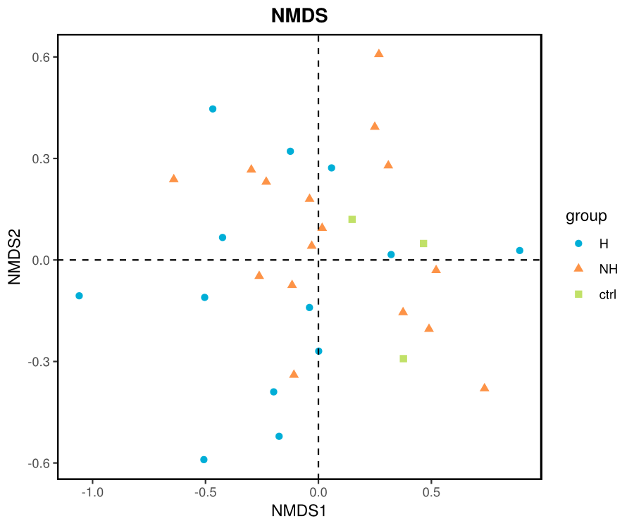
Figure S2. Ordination plot with Non-Metric Multi-Dimensional Scaling (NMDS).

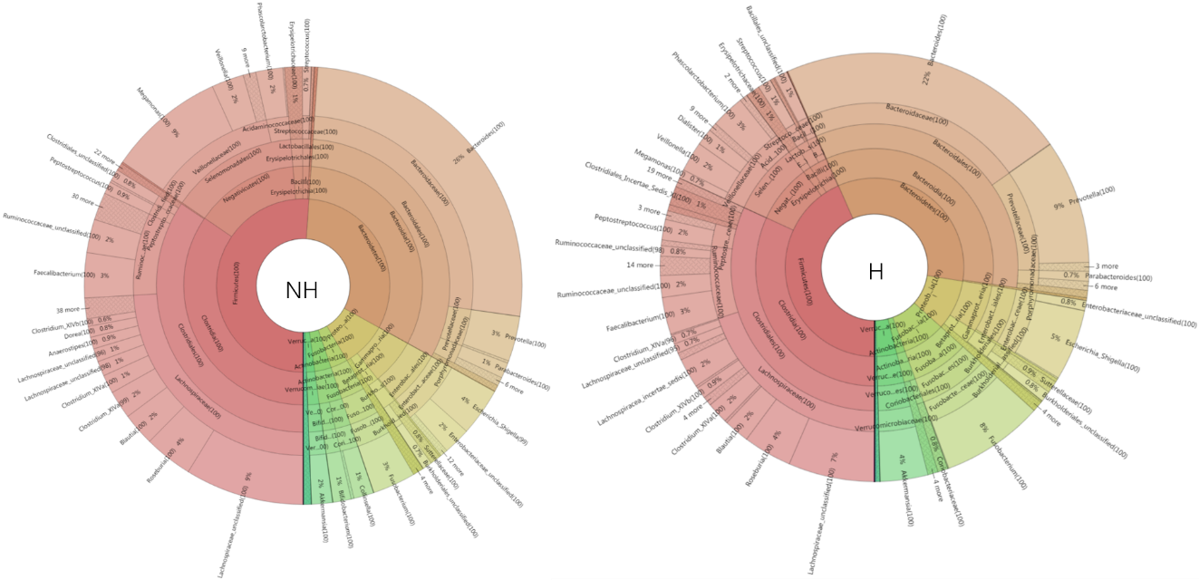
Figure S3. Krona visualization showing microbiome composition of gut microbiota in each group.

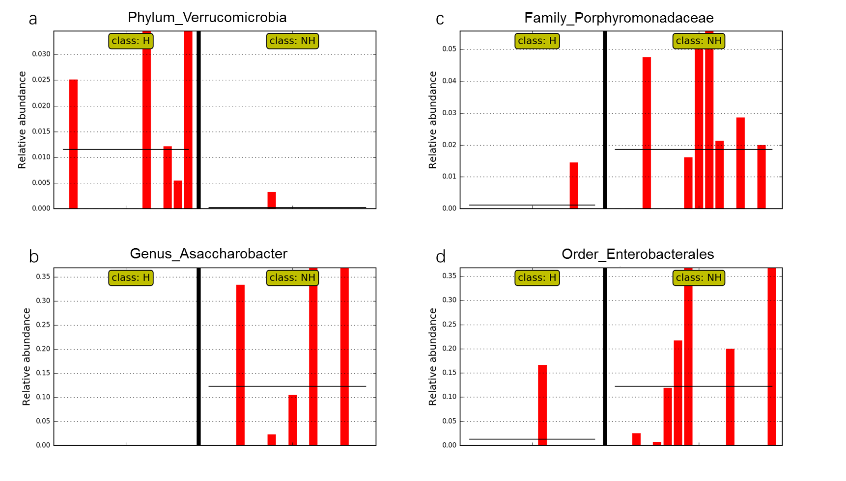
Figure S4. LefSe analysis of differential micro-organisms.

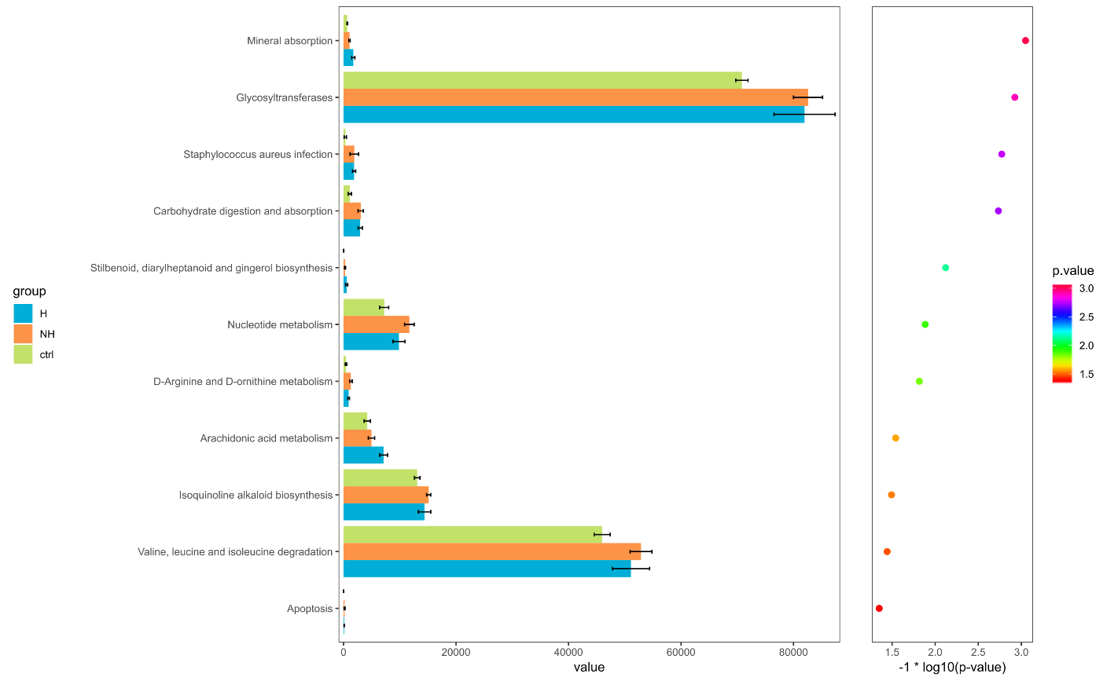
Figure S5. The distribution of KEGG functional categories.

